
Name: ……………………………………………………

C.F. Mark
/20
Total Mark | %
/50

Mathematics Applications
Unit 2, Test 4, 2016 - Chapters 1-4, 13
Calculator Free
25 min allowed

Question 1. [4 marks]
Classify the following variables as:
- categorical or numerical
- nominal, ordinal, discrete or continuous

- Eye colour b) House street numbers
  - i.
  - ii.

- The number of people in a house. d) The length of time waiting in a queue.
  - i.
  - ii.

Question 2. [3 marks]
Scores are normally distributed with a mean of 28 and a standard deviation of 3.75. If the 75th percentile is 35, determine the interquartile range.

Question 3. [3 Marks]
The boxplots below show the test results from Class A and Class B. Each class had the same number of students and an identical test.
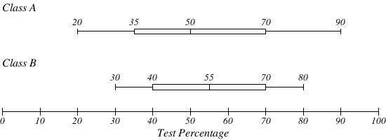

Compare the distributions shown in the boxplots above.

Question 4. [1, 1, 3, 1 = 6 Marks]
The number of runs scored in a cricket season is given in the table to the right.
- Determine the modal class.
Cricket Runs Scored | Frequency
$$0≤x<10$$ | 9
$$10≤x<20$$ | 5
$$20≤x<30$$ | 15
$$30≤x<40$$ | 10
$$40≤x<50$$ | 5
$$50≤x<60$$ | 1

- Calculate the median class.

- Estimate the mean number of runs.

- Explain why your answer to part (c) could only be an estimate.

Question 5. [4 Marks]
The maximum temperature recorded at Perth airport for each day of December in one particular year gave rise to the following data:
Maximum Temperature (°C) | $$20→24$$ | $$25→29$$ | $$30→34$$ | $$35→39$$ | $$40→44$$
Frequency (number of days) | $$3$$ | $$13$$ | $$8$$ | $$6$$ | $$1$$

Display this information as a frequency histogram below.

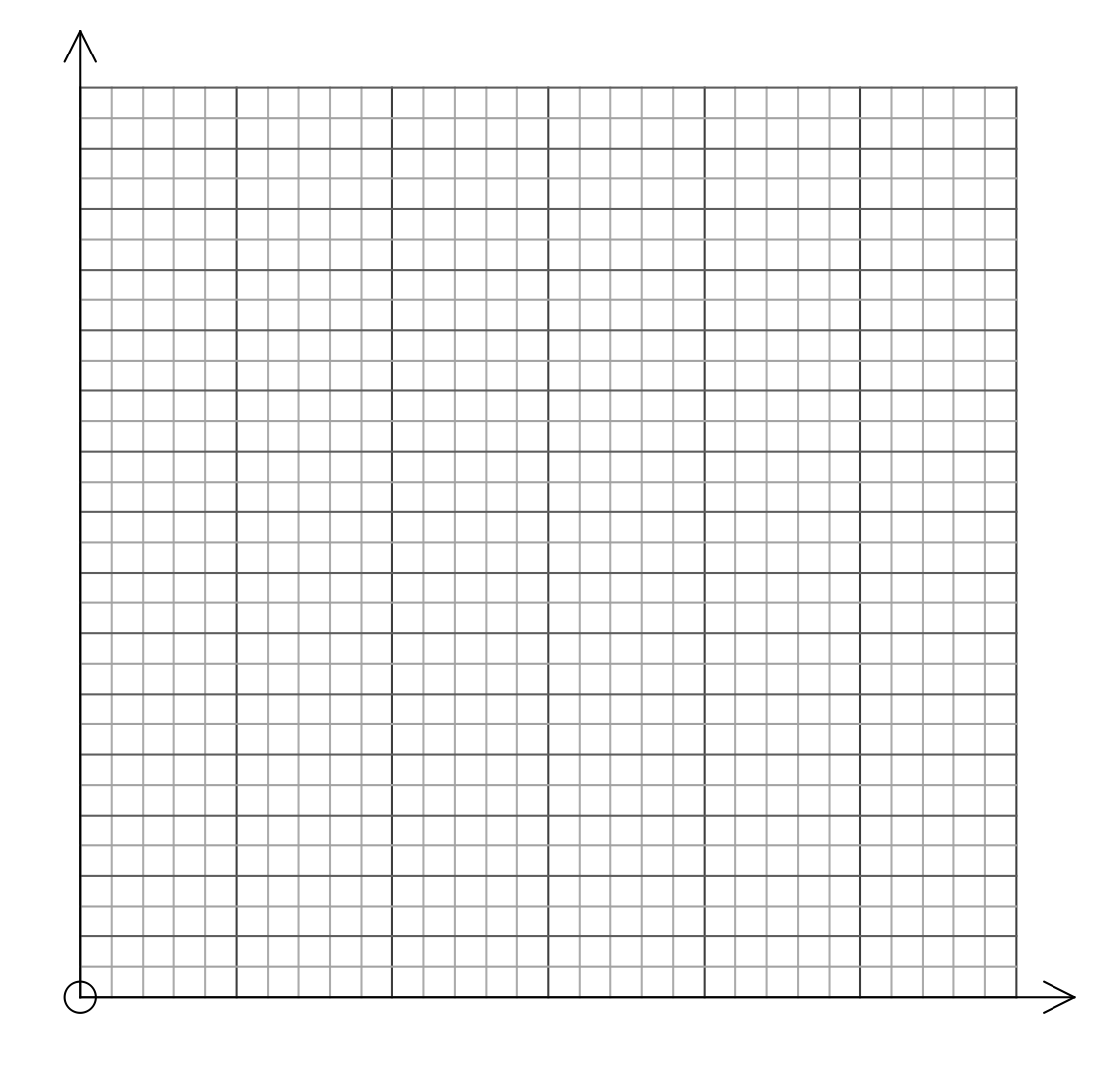


Name: ……………………………………………………

C.A. Mark
/ 30

Mathematics Applications
Unit 2, Test 4, 2016 - Chapters 1-4, 13
Calculator Assumed
Calculators and 1 A4 page of notes allowed
35 minutes allowed

Question 6. [1, 2, 1, 2, 1, 2 = 9 Marks]
The scores, out of 70, in a test are recorded in the group interval table below.
Test Score  (Out of 70) | $$10-19$$ | $$20-29$$ | $$30-39$$ | $$40-49$$ | $$50-59$$ | $$60-69$$
Frequency | 1 | 3 | 4 | 9 | 11 | 3

- How many tests were completed?

- Calculate the
  - Mean.

  - Modal class interval.

  - Median class interval.

  - Range

  - Standard Deviation

Question 7. [2, 3 = 5 Marks]
A weight of 9 gram sachets of saffron are normally distributed with a mean of 9.12 grams and a standard deviation of 0.15 grams.
- What is the probability that a randomly selected sachet of saffron will weigh 9.2 grams or more?

- What are the tenth and ninetieth percentiles for this distribution?

Question 8. [5 Marks]
Given the following data set and the statistical analysis, find the values of $a, b, c$ and $d$.

$$a 5 6 6 b c 12 13 14 d 17 24$$
Mean = 11.25
Range = 21
Median =11
Interquartile Range = 9.5

Question 9. [2 Marks]
If $Χ\sim N\left( 57.2, {12.4}^{2}\right)$determine how many scores are no more than 30, given that there were 3472 scores.

Question 10. [2, 2, 2 = 6 Marks]
Julia recently completed her end of year examinations. Julia finds out from her languages teachers that the Italian exam had a mean of 62% and a standard deviation of 12 and the French exam had a mean of 48% and a standard deviation of 8.
- Julia scored 66 in French. Convert this result to a Z-Score (Standardised Score).

- Julia scored 71 in Italian. Convert this result to a Z-Score (Standardised Score).

- In which subject did Julia attain the “better” result? Justify your answer.

Question 11. [3 Marks]
The 13 boys in a class gained a mean mark of 57% in a test, in which the class mean was 59%. If the class consisted of 20 students altogether find the mean achieved by the girls in the class. Give your answer correct to one decimal place.

